MSc Project Management, Finance and Risk

The Risk Register

What is a Risk register?

https://www.youtube.com/watch?v=voR0FBnC2ZU

A Risk register is a repository of all risks that could impact on a project.

Remember our definition of a project: a unique and timely venture – a TEMPORARY endeavour that has a defined beginning and end and therefore defined scope and resources, aimed at producing a unique product or service.

Our Project Manager is charged with getting things done, applying knowledge; skills tools and techniques to project activities to meet the project requirements, delivering a specific set of operations; identifying activities and managing, mitigating and controlling RISKS required in each phase of the project.

What’s the purpose of a risk register?

The risk register captures and maintains information on all the risks that are identified and relate to the project. So, it allows you to see all the potential risks in one place, to prioritise those risks, decide who owns the risks and how to respond.

As part of business strategy, if you do not have a mechanism to identify, capture and track risks, it’s will be very difficult to structure a coherent plan of potential consequences,

What does a typical risk register contain?
A typical risk register contains:
- A risk category to group similar risks
- The risk breakdown structure identification number
- A brief description or name of the risk to make the risk easy to discuss
- The impact (or consequence) if event actually occurs rated on an integer scale
- The probability or likelihood of its occurrence rated on an integer scale
- The Risk Score (or Risk Rating) is the multiplication of Probability and Impact and is often used to rank the risks.
- Common mitigation steps (e.g. within IT projects) are Identify, Analyse, Plan Response, Monitor and Control.

The risk register is called “qualitative if the probabilities are estimated by ranking them, as “high” to “low” impact. It is called “quantitative” both the impact and the probability is put into numbers, e.g. a risk might have a “$1m” impact and a “50%” probability.
Contingent response – the actions to be taken should the risk event actually occur.
Contingency – the budget allocated to the contingent response
Trigger – an event that itself results in the risk event occurring (for example the risk event might be “flooding” and “heavy rainfall” the trigger)
.
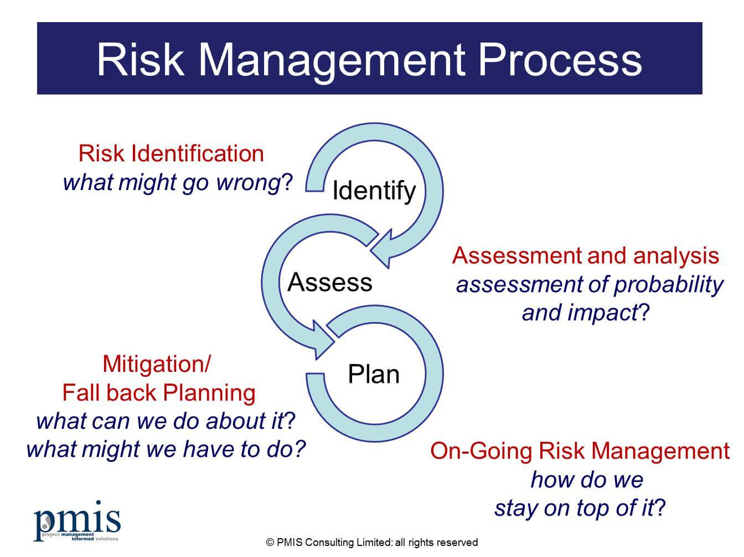

Surprise!

- My lovely family have decided to arrange a surprise birthday party for me and have appointed you as the Project Team
- You have a budget of £14,000; 70 guests will be invited
- The location is at home in the garden in summertime

Task 1:

Please prepare slides addressing and answering the following questions:

Question | Answer
What are we creating? | Balloons.  Birthday cake.  Ice cream cone cupcakes.  Gift wrappers.  Other birthday decorations.  Barbecued beef.
What activities must we do? | Send invitations.  Book a DJ.  Decorate the house.  Bake the birthday cake.  Purchase the cupcakes.  Purchase gifts and gift wrappers.  Barbecue the meat.  Invite guests.  Lure the birthday honouree away from the house for the most of the day.  Shout “surprise!” when the honouree arrives.  Serve the cupcakes and drinks to the guests.  Cut the birthday cake.  Open gifts.
What order must we do them in? | 1. Send invitation Cards.  2. Book the music DJ.  3. Lure the honouree away from the house.  4. Purchase drinks, cupcakes, balloons, decorators, party candles, beef, gifts and gift wrappers.  5. Decorate the house.  6. Prepare and bake the birthday cake.  7. Barbecue the beef.  8. Call and welcome the guests.  9. Serve the guests.  10. Shout “surprise!” when the honouree arrives.  11. Blow the candles and cut the cake as we sing Happy Birthday.  12. Open gifts.
How long will they take? | Activity 1 – Two weeks.  Activity 2 – Two weeks.  Activity 3 – Most of the day.  Activity 4 – 1 hour.  Activity 5 – 3 hours.  Activity 6 – 2 hours.  Activity 7 – 2 hours.  Activity 8 – 30 minutes.  Activity 9 – 2 hours.  Activity 10 – 3 minutes.  Activity 11 – 10 minutes.  Activity 12 – One hour.
When are we doing what? | Activity 1 – Two weeks before the party.  Activity 2 – Two weeks before the party.  Activity 3 – As soon as the honouree takes breakfast.  Activity 4 – Between 9 and 10 am.  Activity 5 – Between 10 am and 1 pm.  Activity 6 – Between 1 and 3 pm.  Activity 7 – Between 3 and 3.30 pm  Activity 8 – Between 3.30 and 5 pm.  Activity 9 – Between 5 and 7 pm.  Activity 10 – Around 5.30 pm.  Activity 11 – Around 5. 35 pm.  Activity 12 – Between 6.30 and 7.30 pm.
How much will the activities cost? | Sending invitations – £1500  Birthday Cake ingredients – £200  Gifts and wrappers – £3200  Party Candles – £10  Party theme decorators – £3000  Drinks and cupcakes – £1550  Music DJ – £3500  Beef - £210  Misc. - £830
What could go beautifully right? | All the guests attend.  All required items available.  Preparations go according to plan.
What could go horribly wrong? | Guests attend in bigger numbers than expected.  The food becomes horrible, for instance, the cake is over baked or the beef is undercooked.  The drinks run out.  It becomes rainy.  The DJ becomes committed elsewhere at the last minutes.

Task 2

Please have a go at completing this RISK REGISTER for the Birthday Party and prepare a slide. I have provided some categories to get you started, for example “Guests”. So, 1.1, what do you think the nature of the risk is in this category?

Birthday Party Risk Register

Risk Category | Nature of the risk | Risk No | Probability (P) (1-3) | Impact (I) (1-3) | Risk score  (P x I) | Mitigation | Contingency | Action by | Action when
Guests | More guests. | 1.1 | 2 | 2 | 4 | Remind guests about the party.  Confirm attendance. | Use the misc. money to purchase more cupcakes and drinks. | Guests bringing relatives that were not in the plan. | Guests have not confirmed how many friends they would bring.
 | Less Guests. | 1.2 | 2.5 | 1.4 | 3.5 | Remind guests about the party.  Confirm attendance. | Request the attending guests to make the party livelier. | Weather changes.  Traffic.  Other last minute changes in plans. | No confirmation received on potential changes in the plan.
Food | Wrongly barbecued beef. | 2.1 | 1 | 2.9 | 2.9 | Close manning of the grill. | Buy more cupcakes to cover up for the bad meat. | Over cooking or under cooking. | The grill is not closely monitored.  There is a lack of a good barbecue cook.
 | Wrongly baked cake. | 2.2 | 1 | 3 | 3 | Follow the recipe’s instructions closely. | Order a ready-made cake from the nearest store. | Over baking or mixing ingredients wrongly. | The recipe is not carefully followed.
Drink | Running out of drinks. | 3.1 | 2 | 2.5 | 5 | Monitoring the drinks to ensure it is noted before the last two or three bottles. | Order more drinks from the nearest store. | More than expected number of guests. | All the bottles are empty.
Weather | The evening becomes rainy. | 4.1 | 2.5 | 2 | 5 | Sheltering the barbecue grill.  Keep confirming the guest’s attendance. | Ensure everything is orderly and sheltered.  Confirm guest attendance. | Natural Weather changes. | The rain comes unexpectedly.
Music | The DJ gets committed elsewhere. | 5.1 | 1.2 | 2 | 2.4 | Confirm the DJ’s schedule frequently. | Use the family’s music playlist. | Lack of communication with the DJ. | The DJ gets a better contract on that day and taking it because of failure of communication.
.

